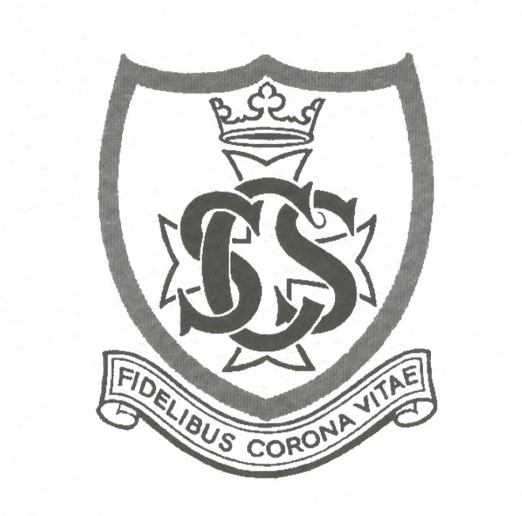
OSSS Membership Form

Please complete the form and send it with your cheque to:

Veronica Colin, 3 Craigton Cottages, Craigton, Milngavie G62 7HQ

- I should like to join the Old St Stephen's Society and enclose a subscription of £6.

Title (block capitals)………………….Forename(s)……………………………………
Surname………………………………………………………………….…………..
Maiden name………………………………………………………………………….……….

I was at SSC between 19……. and 19…….

Address…………………………………………………………………………….…
……………………………………………………………………………………….…
………………………………………………………………………………………….
Postcode……………………….………….

Tel: …………………………………………………………………………………….
Mob:……………………………………………………………………………………

Email: …………………………………………………………………………………

